GDD – Web Development

Title:

Blastin’ Bandits

Genre:

Rail-Shooter

Market Research:

* House of the Dead
* Time Crisis

Game Overview:

The game is a rail-shooter in the vein Tim Crisis themed around a wild-west train robbery. In the game bandits will pop out of cover, give the player a 2 second window to react to shoot them or take damage, damage can healed by shooting bottles that appear in the level. There will be three levels with a boss at the end.

Core Objective:

Get to the end of the train and defeat all the bandits on the train.

Expected Experience:

The expected experience will be a fun, simple game that can be played with only a mouse.

Gameplay Theme:

Wild-West.

Game Structure:

Features Implemented (highlight the distinctive features):

Player Mechanics:

* Click on enemies to shoot them
* Click on bottles to heal
* Click on Cylinder to reload

**Game environment**

Sketch and describe the GUI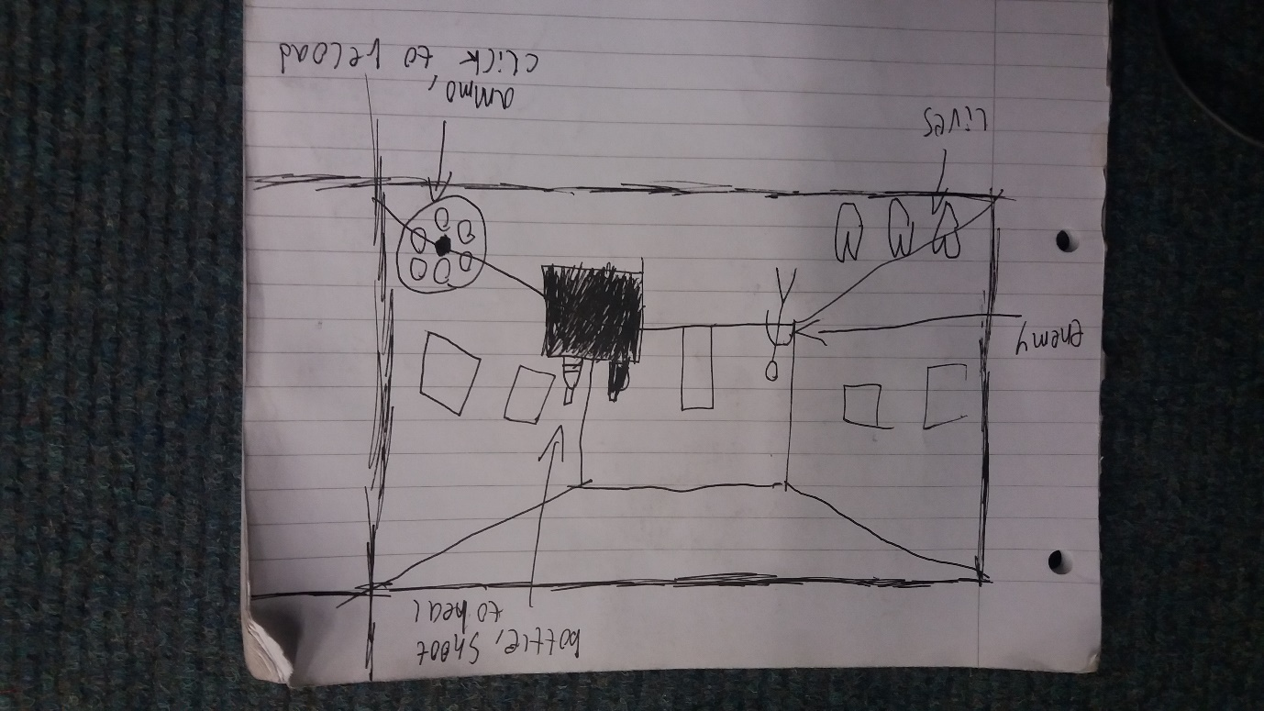

Sketch each level / environment

Describe the scene and the objects on it

Describe play sequence of the intended gameplay including the interactions between objects and player and its consequences

**Implementation**

Highlight the design patterns implemented in the game